Your Organization’s Purpose

- Mission Statement (Brief paragraph describing the reason for your organization’s existence)
We exist to make a profit. We do this by offering the widest, most complete variety of machine embroidery products in the world at a one stop destination.
- Vision Statement (Where does your organization want to be in 5 years? This is your “dream”.)
- Be able to sell the business
- Shift to a multi-million dollar company
- Become 10x our current size
- Good reputation
- Expand our website product base from 20,000
- Develop kits to sell fabric and supplies
- Become more user friendly

- What is the primary purpose of the site (What is the main thing you want users to do when they come to your site?)
- Buy embroidery thread, notions, etc.
- Learn more about things and develop our customer’s knowledge base
- Give feedback through a review page
- Make a profit

Corporate Identity (if different from the existing website)
Your corporate identity includes logos, trademarks, catch phrases/ slogans, colors, or other assests that need to be a part of the Web site design
- Do you currently have a corporate logo?
Yes. Our logo is designed to communicate 3 major products that we sell: Thread, Needles, Stabilizer.

Of “Yes”, please provide either a URL or a digital copy if possible. If all you have is a paper copy, please provide it, along with any specification (color, typeface, etc) you have.
- What is your corporate color scheme? (If you don’t have any, we will define your color preferences later)
None in particular, but be aware of different color meanings

- Do you have a phrase or motto that describes your identity or purpose? If so, what is it? (Examples: “Life Made Easier”, “Where America Shops for Shoes”, “Debt Relief is a Phone Call Away”, “Defending the American Dream”, “Learning to Do, Doing to Learn, Earning to Live, Living to Serve.”)
Best Products, Best Selection, Best Value for Machine Embroiderers

- Do you have printed marketing materials?
Yes, we have:
- A catalog
  - http://www.discountembroiderysupply.com/index.php?main_page=catalog
- Business Cards
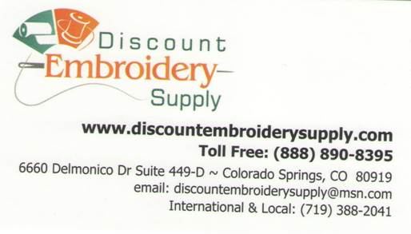

- How do you currently communicate with your customers or constituents, in order to build a stronger relationship with them (increased sales, donations, participation, lead, etc.)? (Check all that apply)
- 20,000 customer emails
- Newsletters
- Social media
- Fresh Desk/ Voicemails/ Emails
- Phones (rarely)

Your Customers/ Constituents
Although we obviously are designing a Web site for your organization, we must appeal to the users of the site in all aspects of design and functionality. It is critically important for us to understand who is or will be buying your products or using your services or supporting your cause.
- Primary Audience Demographics (This is your target customer or constituent. We use this information to design a “look and feel” consistent with the demographics of your primary audience.)

  - User Characterizations
(Descriptive terms, such as “High School Students,” “Disabled Veterans,” “Coffee Drinkers,” “Young couples seeking childcare,” “Cigar aficionados,” “Seasoned travelers seeking adventure”)
- Machine Embroidery
- Quilters Embroidery
- Notions
- Thread
- Stabilizer

  - Age Range (Check all that apply)
- Customer base is typically 60+ years
  - Grand parents
- Small businesses

  - Gender (Check all that apply)
- Predominately female

  - Annual income range (Check all that apply)
- Retired
- Fixed income

  - Highest Education level (Check all that apply)
- BA Degree

- User Technology usage
  - How computer- and Web- savvy are your primary and secondary/tertiary users?
- For their age group, they tend to be slightly below to exactly at average
  - IE they know how to use the web and what their general expectations are and should be

  - How do you want users to be able to access your Web site? (Check all that apply)
- URL only/ Google Search

  - Is there a corporate standard browser your users are required to use? (This primarily applies to intranet applications)
- No

  - Is there a corporate standard computer type/ operating system your users are required to use? (This primarily applies to intranet applications)
- No

